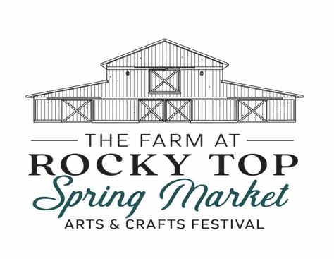
The Farm at Rocky Top
2910 Lee Road 145
Salem, AL 36874

May 17 & 18,
2025
9am -4pm CST

VENDOR’S APPLICATION

Name: ___________________________________________________________________
Business Name: ____________________________________________________________
Address: __________________________________________________________________
City: ______________________ State: ______________________ Zip: _______________
Phone #: _______________________ Email: _____________________________________
Website: __________________________________________________________________
FB: _____________________________________ IG: _______________________________

SELECT BOOTH OPTION:

_____ Single (12’ x 12’) -$75 _____Double (24’ X 12’) - $150
____ 12’x 10’ Inside barn - $125 (limited space)
____ Electricity outside (limited)- $15 (amps needed____/extension cord not provided)
_____ Food Vendor outside (12’ x 12’)-$150 _____ Food Truck - $150
Does your booth require a generator (not provided): _____Yes _____No

TOTAL AMOUNT DUE IF ACCEPTED: ___________

(DO NOT SEND MONEY WITH APPLICATION)

ART/CRAFT/FOOD INFORMATION
(Circle your vendor category)

Antiques/Furniture
Children’s Activities
Clothing/Boutique
Fiber Art/Basket Weaving
Foods, Made on site
Foods, Packaged
Garden Accent
Home Décor
Jewelry
Leather
Metals
Miscellaneous
Paintings/Photography
Pottery/Ceramics
Soaps/Spa/Candles
Toys
Wood/Glass
Wreaths/Floral

Description of Work/Arts/Crafts/Food: ___________________________________________________________________________________
______________________________________________________________________________________________________________________________________________________________________

FOOD VENDORS:

List ALL foods/drinks you will be selling:____________________________________________
________________________________________________________________________________
________________________________________________________________________________
**Once approved, you cannot add to your menu unless approved by committee.

Equipment/mobile unit info: Height: _____ Length (including hitch): _____ Width: _____
Which side do you serve out of? ______________
Will you also be selling drinks? ________________

APPLICATION SUBMISSION
Deadline: May 10, 2025

Submission checklist: Mail to: Email to:
- Vendor Application The Farm at Rocky Top jan@thefarmatrockytop.com
- Photos (3) 2910 Lee Road 145
- Release form Salem, Alabama 36874

TERMS AND AGREEMENT

My signature verifies that I have read the rules and regulations associated with this application and hereby agree to comply with said rules and regulations. I understand the completion of this application does not guarantee acceptance. Failure to comply with ALL rules and regulations may result in forfeiture of show and deposits.

Signature: ______________________________________ Date: ________________

..

RELEASE AND HOLDS HARMLESS AGREEMENT

For and in consideration of my approval to participate in The Farm at Rocky Top’s Spring Market, I, the undersigned applicant, do hereby agree to release and forever discharge The Farm at Rocky Top, it’s owners, agents, employee’s and successors, from any and all claims, responsibility, personal liability, loss or damage in connection with the festival.

Signature: _________________________________ Date: _______________

